

Project Title- MONITORING SYSTEM USING ML FOR SOLDIERS
Course No. KEC-753
Semester: VII TH
In
I.T.S Engineering College

Submitted for partial fulfilment of award of

BACHELOR OF TECHNOLOGY
Degree in

Electronics & Communications Engineering

Submitted by

S. NO | STUDENT NAME | STUDENT ROLL NO. | MOBILE NO.
01. | AMBIKA | 2002220310004
02. | RAHUL RAJ | 2002220310016
03. | RAJU KUMAR | 2002220310017

Submitted to
(Prof. ………………………….. )
Project: Approved ---Not Approved

DEPARTMENT OF COMPUTER SCIENCE & ENGINEERING

I.T.S ENGINEERING COLLEGE

46, KNOWLEDGE PARK-III, GREATER NOIDA

Affiliated from Dr. A.P.J Abdul Kalam Technical University, Lucknow Session 2020-2024

ABSTRACT

Project Title: MONITORING SYSTEM USING ML FOR SOLDIERS

Problem Statement:

Modern warfare demands safety and effective communication, which current systems struggle to provide. This report proposes a unified system leveraging bio-sensors, GPS, and wireless communication for real-time health monitoring and location tracking. By bridging communication gaps, monitoring health, and providing accurate location data, this system aims to enhance soldier safety and optimize military operations. Unlike existing solutions, it addresses unique military challenges with specialized wearables and communication protocols like ZigBee and LoRa WAN. Further, K-Means clustering extracts actionable insights from data, improving control unit decision-making. In essence, this proposed system fills the gaps in current soldier monitoring technology, offering a comprehensive solution for improved safety and operational efficiency in challenging battlefield environments.
Rationale for topic selection:
Current warfare demands seamless communication and real-time health monitoring for soldier safety and efficient operations. This report proposes a comprehensive system addressing these crucial needs.
Existing challenges:
- Communication gaps between soldiers and control units hinder military operations.
- Lack of real-time health monitoring complicates search and rescue efforts.
- Limited effectiveness of traditional communication methods like GSM in harsh environments.
Proposed solution:
- Integration of bio-sensors, GPS, and advanced wireless communication (ZigBee, LoRaWAN) for real-time health monitoring and location tracking.
- Tailored design for military contexts, addressing unique challenges like lightweight wearables and reliable communication in difficult terrain.
- Advanced data analysis with K-Means Clustering for extracting actionable insights and supporting informed decision-making at the control unit.
Benefits:
- Enhanced soldier safety through real-time health monitoring and accurate location data.
- Optimized military operations with improved communication and situational awareness.
- More informed decision-making at the control unit based on deeper data analysis.

Objective of Project:

The goal of this project is to develop an integrated health monitoring and location tracking system for soldiers, utilizing biomedical sensors, GPS technology, and advanced communication modules. By seamlessly collecting and analysing real-time health data, the system aims to enhance the safety of soldiers in battlefield scenarios. The incorporation of machine learning algorithms further enables insightful data clustering, aiding control units in timely decision-making. Ultimately, the project seeks to provide a robust, lightweight solution for improving the overall coordination and responsiveness of military operations.
What will this project do?
- Track soldiers' health (heart rate, temperature, etc.) and location in real-time.
- Send data from soldiers to squad leaders and then to the base station.
- Use smart algorithms to understand the data and help commanders make better decisions.
- Use Data Analysis to predict the Emotional health and feelings of individuals.
Key Features:
- Wearable sensors monitor health and GPS tracks location.
- Rugged design works in harsh environments like mountains and bad weather.
- Secure communication using special radio technologies (ZigBee and LoRaWAN).
- Cloud storage keeps all data accessible.
- Smart algorithms group data into categories (healthy, unwell, etc.) for easier understanding.
- Easy-to-use interfaces for soldiers, squad leaders, and commanders.
Benefits:
- Keep soldiers safe by monitoring their health and location.
- Help commanders make better decisions during operations.
- Improve communication and efficiency in military operations.

Our soldier monitoring system uses two special radio technologies: ZigBee for nearby communication and Lora WAN for long-distance communication. We skip unreliable phone signals (GSM/RF) because they may not work in mountains or bad weather.
ZigBee helps soldiers send health and location data to their squad leader. LoRa WAN then sends that data to the base station, even from far away.
All the data, like heart rate and location, gets stored in the cloud so everyone can see it. We use a special algorithm to understand the data better, helping commanders make smart decisions.
Our system basically means soldiers can talk to their base even in tough places, and everyone can use the data to keep soldiers safe and make better plans.

Scope of the Project:
The future of this soldier monitoring system holds exciting possibilities in several areas:
- Human Activity Recognition: Integrating gyroscope and accelerometer data with machine learning can decipher soldiers' actions, boosting situational awareness.
- Emotional State Monitoring: Additional sensors like blood pressure and electrodermal activity can assess a soldier's emotional state, distinguishing between calmness and distress for a more comprehensive health picture.
- Improved Routing Algorithms: Implementing more reliable and energy-efficient routing algorithms will enhance data transmission efficiency and optimize battery consumption in extended operations.
- Ubiquitous Computing Integration: Embracing ubiquitous computing can create a seamless environment where physical and computational infrastructures merge, providing soldiers with new functionalities without bulky equipment.
- Dynamic Squad Leader Selection: Developing dynamic cluster-head selection algorithms for assigning squad leaders will improve flexibility and leadership adaptability based on real-time conditions.
- Network Expansion: Optimizing communication protocols and ensuring scalability will allow the network to accommodate larger numbers of soldiers and devices, adapting to various military scenarios.
- Enhanced Security Measures: Implementing advanced encryption techniques and cybersecurity protocols will further safeguard sensitive data against evolving threats in military landscapes.
- Integration with Emerging Technologies: Remaining at the forefront of innovation involves incorporating advancements in sensor technology, communication protocols, and machine learning algorithms.
- Cross-Domain Applications: Exploring applications beyond military operations, such as search and rescue missions and disaster response, can leverage the system's adaptability where real-time health monitoring and location tracking are crucial.
- User Interface and Experience Enhancements: Continuously improving the user interface and experience based on soldier feedback and emerging human-computer interaction technologies will boost the system's usability and acceptance among military personnel.
- This future holds significant advancements in soldier monitoring technology, promising greater safety, efficiency, and communication in military operations.

Methodology:
The methodology for the proposed soldier monitoring system can be described through several key points:
Hardware Integration:
- Selecting and integrating essential hardware components like Arduino MEGA 2560, bio-sensors, GPS modules, ZigBee and LoRa WAN modules, bomb detector, ECG module, etc.
- Ensuring compatibility, lightweight design, and unobtrusive wearability for soldier mobility.
Communication Framework:
- Developing a robust communication framework with ZigBee for local soldier-to-soldier communication and Lora WAN for long-range transmission to the base station.
- Excluding unreliable GSM and RF methods due to limitations in challenging environments.
Data Transmission and Cloud Integration:
- Implementing a secure and efficient data transmission system from soldiers to squad leaders and the base station.
- Utilizing cloud-based storage for centralized data access and analysis.
Data Analysis and Prediction:
- Utilizing the K-Means Clustering algorithm for advanced data analysis of health metrics and location information.
- Categorizing data into clusters (healthy, ill, abnormal, deceased) for actionable insights and decision-making.
Usability and User Interface:
- Designing user-friendly interfaces for soldiers, squad leaders, and control unit personnel.
- Ensuring ease of use, minimal training requirements, and clear data presentation.
Environmental Adaptability:
- Addressing environmental challenges like high altitudes and adverse weather conditions.
- Employing rugged hardware and robust communication protocols for reliable operation.
Security and Privacy:
- Implementing robust security measures to protect sensitive data.
- Complying with privacy regulations and guidelines.
Documentation and Training:
- Providing comprehensive documentation for system deployment, maintenance, and troubleshooting.
- Conducting training sessions for users to ensure effective system utilization.
Evaluation and Validation:
- Conducting thorough testing and evaluation of the system in controlled and simulated environments.
- Validating the system's accuracy, reliability, and effectiveness in real-world scenarios

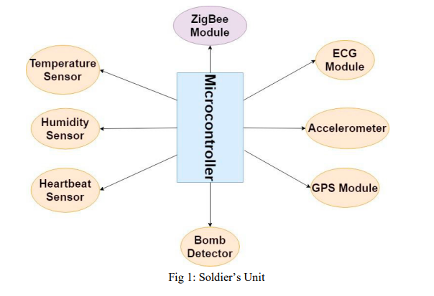


A
RDUINO

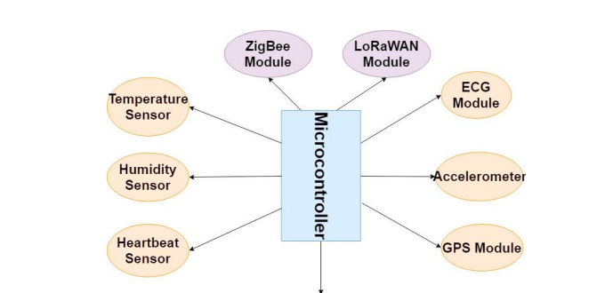

A
RDUINO

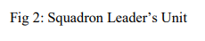
Software And Technology Use:
Microcontroller Firmware:
- Arduino IDE: This open-source programming environment will be used to develop the firmware for the Arduino MEGA 2560 microcontroller. The firmware will handle sensor data acquisition, basic data processing, and communication with other modules.
Data Transmission and Security:
- ZigBee libraries: Libraries like Microchip MPLAB XCode IDE Tools will be used to manage communication between soldiers and squad leaders via the ZigBee modules. Security protocols like AES encryption can be implemented within the libraries for secure data transmission.
- LoRaWAN libraries: Tools like Semtech LORA Cloud Server Stack libraries will be used to handle long-range communication between squad leaders and the base station using the LoRaWAN modules. Again, security protocols like AES encryption will be used to protect sensitive data.
Data Cloud Storage and Analysis:
- Cloud Platform: Platforms like Google Cloud Platform, Amazon Web Services, or Microsoft Azure can be used for cloud-based data storage and analysis. These platforms offer scalable storage solutions and a variety of tools for data analysis, like BigQuery and Azure Machine Learning.
- Machine Learning Libraries: Libraries like scikit-learn in Python or TensorFlow can be used to implement the K-Means Clustering algorithm for data analysis. These libraries provide efficient algorithms and tools for data visualization and interpretation.
User Interface and Visualization:
- Web Development Tools: Front-end frameworks like ReactJS or AngularJS can be used to develop user interfaces for soldiers, squad leaders, and control unit personnel. These frameworks offer interactive dashboards and visualizations for displaying health data, location information, and other relevant information.
Security and Privacy Frameworks:
- Cryptography Libraries: Libraries like OpenSSL can be used to implement robust encryption algorithms for protecting sensitive data at rest and in transit.
- Access Control Tools: Identity and access management tools can be used to restrict access to data based on user roles and permissions.

Contributors:
- AMBIKA
- RAHUL RAJ
- RAJU KUMAR

